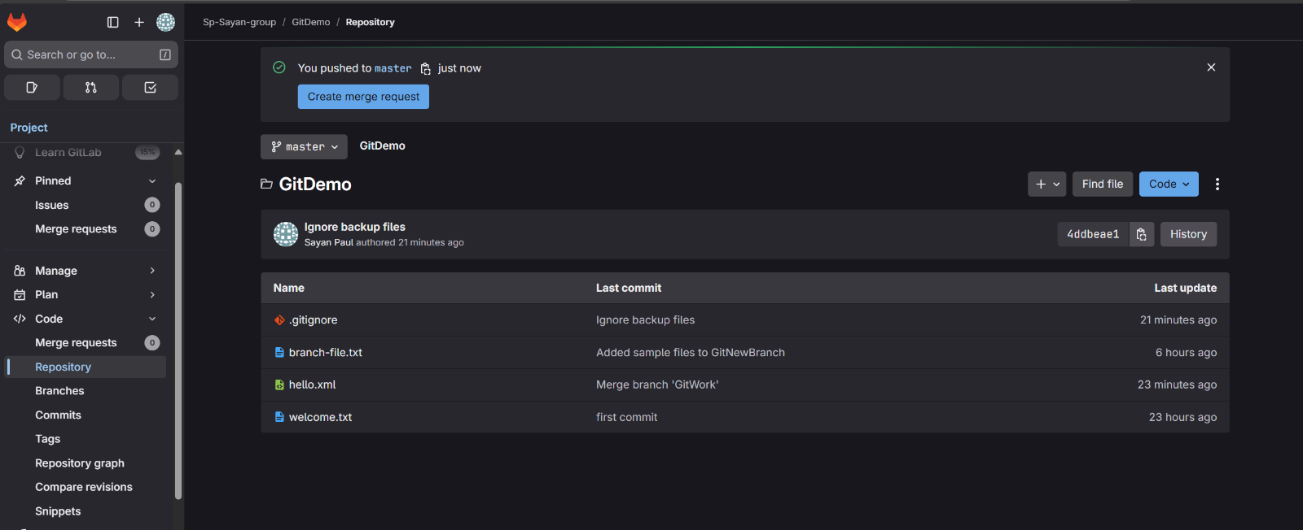**Commands:**

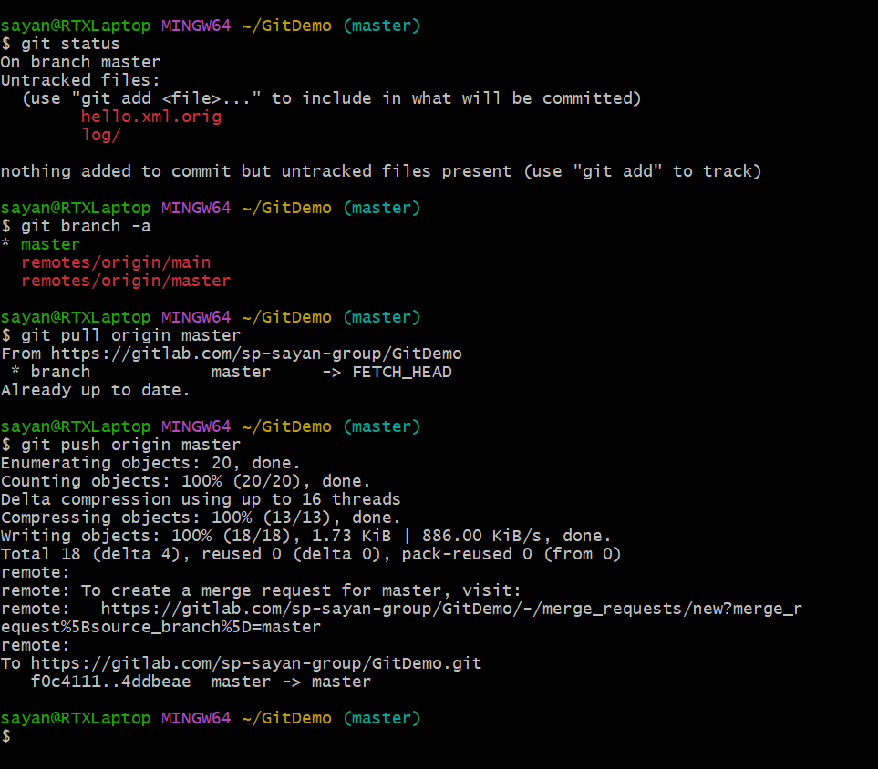

//check status

//list branches

//pull from remote

//push to remote

**In Gitlab, the changes are visible**